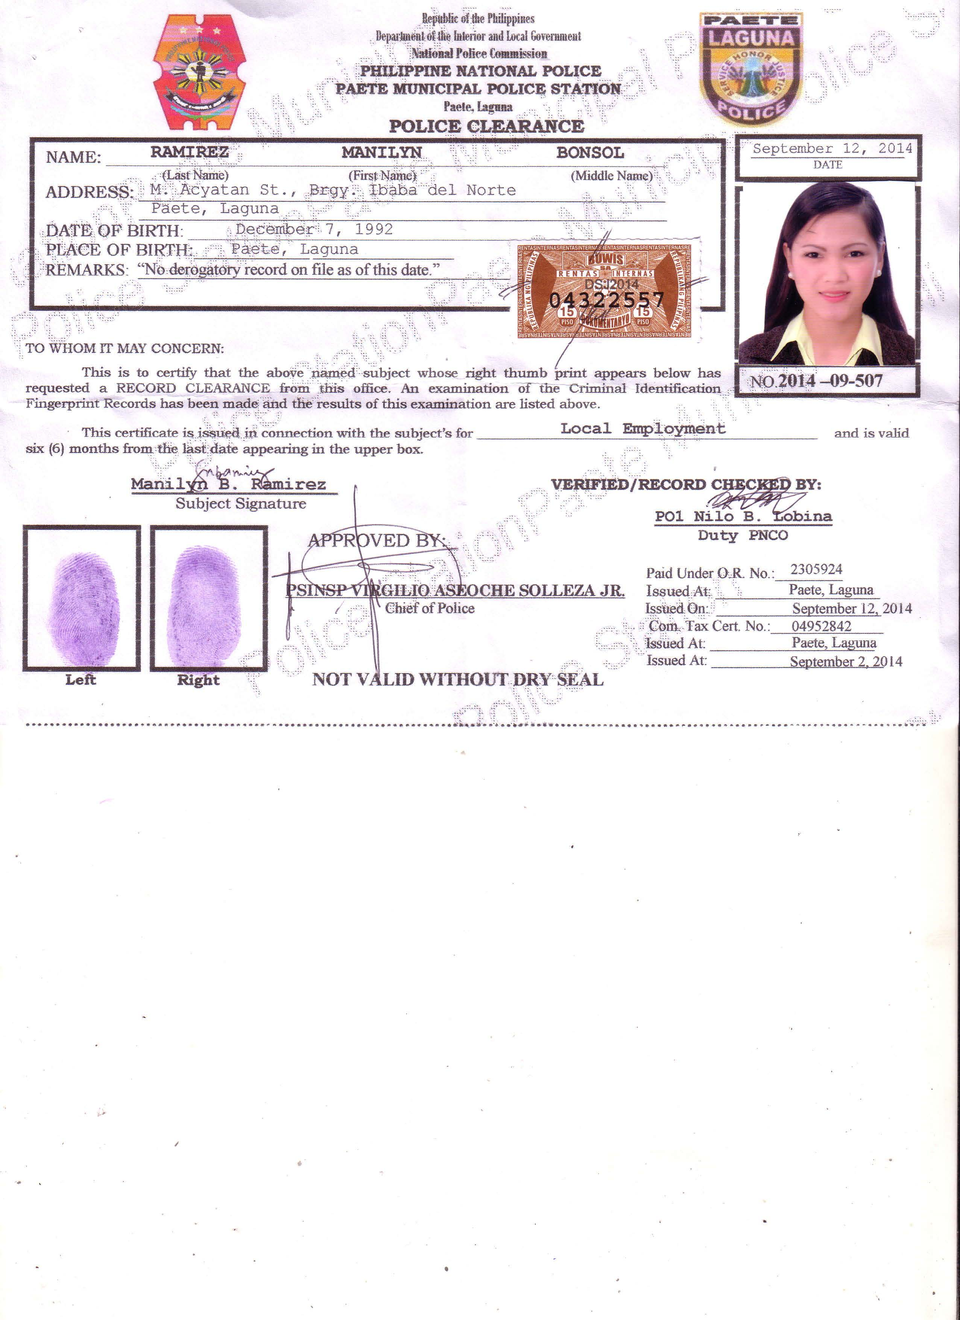**Manilyn Bonsol Ramirez**

156 M. Acyatan St. Brgy 9 Ibaba del Norte

Paete, Laguna

Mobile No. 09075439715

Email Add: [manilynramirez027@yahoo.com](mailto:manilynramirez027@yahoo.com)

**QUALIFICATIONS**

* Graduated of Bachelor of Science in Business Administration Major in Management with Computer Application.
* Accomplished 400 hours On-the-Job Training at Rural Bank of Magdalena-Paete Branch.
* Can work efficiently with Microsoft Offices (Word, Excel, Power Point, and Outlook).
* Well-developed in communication skills (verbal or non-verbal), patient, resourceful, and punctual.
* Well-trained in handling documents.
* Can perform duties/tasks assigned by her superiors in support of the goals and objectives of the business.

**WORK EXPERIENCE**

**Practicum Works:**

On-the-Job Training - Record Keeping

Rural Bank of Magdalena - Encoding

Paete Branch - Scanning and Printing

Paete, Laguna - Answer Telephone Calls

April 23, 2012 to July 31, 2012 - Journalizing Transactions

Production Operator

Transitions Optical Phils, Inc.

Blk 4, Lt 1 Star Ave., Liip Mamplasan, Binan, Laguna

July 8, 2013 to December 5, 2013

Office Encoder

Fujitsu Die-Tech Corporation of the Philippines

113 East Science Avenue, Special Export Processing Zone, Laguna Technopark, Binan, Laguna, Philippines

February 19, 2014 to May 10, 2014

Sales Staff

Fujitsu Die-Tech Corporation of the Philippines

113 East Science Avenue, Special Export Processing Zone, Laguna Technopark, Binan, Laguna, Philippines

September 22, 2014 up to Present

**EDUCATIONAL ATTAINMENT**

Tertiary ACTS Computer College

Sta. Cruz, Laguna

Course : Bachelor of Science in Business

Administration Major in Management with Computer Application

Position Paper : An Assessment on the Marketing Strategies

Implemented by the Selected Handicraft Stores in Paete, Laguna

Graduated : S.Y. 2012-2013

Secondary Poten & Eliseo Quesada Memorial National High School

Paete, Laguna

Graduated : S.Y. 2008-2009

**PERSONAL DETAILS**

Age : 23 yrs. old

Date of Birth : December 7, 1992

Birthplace : Paete, Laguna

Gender : Female

Height : 5’2’

Religion : I.F.I (Aglipay)

Marital Status : Single

Language(s) Spoken : English and Filipino

Father’s Name : Nestor M. Ramirez

Occupation : Tricycle Driver

Mother’s Name : Marina B. Ramirez

Occupation : Deceased

**SEMINARS ATTENTED**

September 04, 2010 - Personality Development

October 22, 2011 - Solid Waste Management Through

Vermicomposting Technology

February 09, 2012 - ACTS 1st BEST (Business, Entrepreneur,

Synergies Symposium Thrust of a Sustainable Economy)

March 02, 2013 - ACTS 2nd BEST (Business, Entrepreneur,

Synergies Symposium Thrust of a Sustainable Economy)

March 21, 2013 - Job Hunting Symposium

November 10, 2015 - Quality Customer Service

December 16, 2015 - Developing and Controlling QMS Documents and Records / DC Toolbox Awareness

**CHARACTER REFERENCES**

**Dr. Ma. Luz P. Salvador**  **Mrs. Lolita A. Acupanda**

College Dean Branch Manager

ACTS Computer College Rural Bank of Magdalena-Paete

Sta. Cruz, Laguna Paete, Laguna

Tel. No. 501-1484 Tel. No. 557-2207

**Mr. Alvin Comia**

Asst. Sales & Design Manager

Fujitsu Die-Tech Corporation of the Philippines

Contact No. 09175924500